寫作信箱題目1
Index

請根據下列資料寫一篇50字的短文介紹Linda。

1.  Personal Data  Last name: Brown  First name: Linda  Nationality: Canadian  Date of Birth: Aug. 7, 1981 | 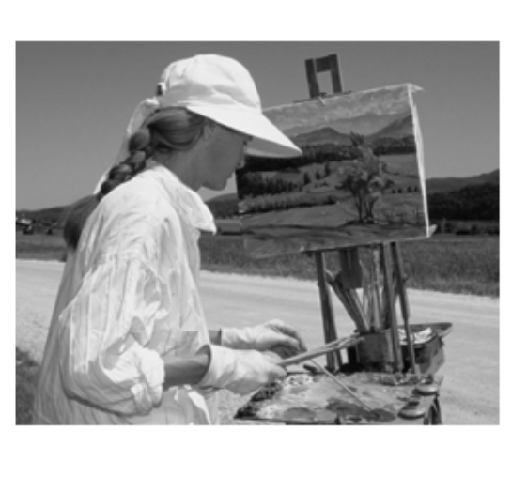  2.
3. Linda’s boyfriend


